# **Northern Rockies Fire Science Network**

# Annual Report FY 2024

**Section 1:**

Which of the following key fire science topics[1] did your Exchange contribute to this year? Select all that apply. Highlighted fire science topics were areas the Northern Rockies Fire Science Network (NRFSN) focused in FY 2024.

* 1. ***Wildlife:*** Fire effects on wildlife and habitat
  2. ***Invasive plant species***: Fire effects on and interactions with invasive weeds and grasses
  3. ***Vegetation***: Fire effects on and interactions with vegetation
  4. ***Soil***: Fire effects on soil
  5. ***Watershed processes***: Fire effects on watersheds including erosion, riparian habitat, water quality, etc.
  6. ***Postfire recovery and management***: Efforts undertaken to repair or improve fire damaged lands or repair or replace minor facilities damaged by fire
  7. ***Fire behavior***: Measurement or prediction of the way a fire reacts to influences of fuel, weather, and topography
  8. ***Fire regimes***: Description of current or historical patterns of fire occurrences, specifically frequency, size, and severity in a given area or ecosystem
  9. ***Fuels management***: Assessment, planning or effectiveness of fuels treatments or the practice of controlling wildland fuels through mechanical, chemical, biological, or manual means (excludes prescribed fire)
  10. ***Prescribed fire***: Assessment, planning, or effectiveness of prescribed fire or a wildland fire originating from a planned ignition in accordance with applicable laws, policies, and regulations to meet specific land management objectives
  11. ***Smoke, air quality, and health***: Assessing and managing the effects of smoke from wildland fire and its impacts on air quality and mitigating human-caused visibility and health impacts
  12. ***Wildland urban interface and infrastructure***: Effects of wildland fire or mitigation strategies on the area where structures and other human development meets undeveloped wildland fuels, including fire-adapted communities, visitors, and housing structures
  13. ***Firefighter safety and incident management***: Organized response to wildfire to protect life, public health and safety, infrastructure, and to minimize disruption of governmental, social, and economic services
  14. ***Social science and human dimensions***: Community recovery from wildfire, societal perceptions of wildland fire and mitigation actions, or effectiveness of partnerships and collaborations
  15. ***Indigenous knowledge***: Fire management or ecological knowledge, practices, or skills developed in indigenous communities and passed down from generation to generation
  16. ***Economic impacts***: Monetary impacts, valuation of ecosystem services, and cost-benefit analysis

**Section 2:** The following are three NRFSN success stories:

# Traditional Knowledge and Fire Events

**Key fire science topics:** Firefighter safety and incident management, Social science and human dimensions, Indigenous knowledge, Wildland urban interface and infrastructure, Prescribed fire

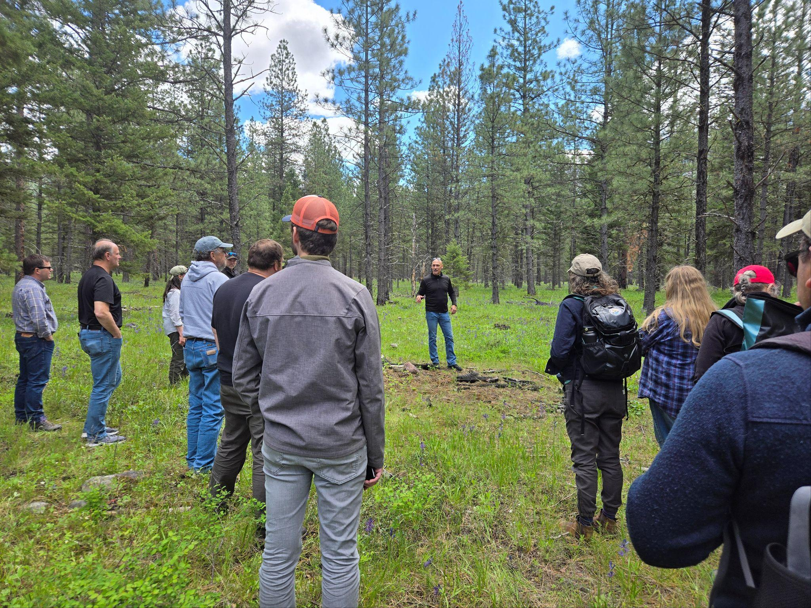**Impacts:** Connectivity, Conceptual

As part of the FSEN Annual Meeting, which took place near Polson, MT in early June, the Northern Rockies Fire Science Network coordinated a field trip with the Confederated Salish and Kootenai Tribes (CSKT). Convening at the CSKT Division of Fire Management building in Ronan, attendees of the meeting learned about wildfire and forest management on the Flathead Reservation. The day began with an introduction from Pend D’Oreille elder, Stephen Small Salmon who warmed up the audience with a few jokes and talked about his memories of fire on the landscape. The field trip was led by Fire Management Officer for the CSKT, Ron Swaney, who gave a presentation on fire history and management and then led the meeting participants to several locations on the Flathead Reservation to observe and discuss past wildfires and current forest management techniques. In addition to the field trip, the annual meeting was hosted with a focus on tribal engagement.

The Northern Rockies Fire Science Network is also working on another project with the Confederated Salish and Kootenai Tribes. The project, led by Antonio Torres, will be a video about traditional fire featuring clips of elders and other tribal members from several field trips and listening workshops with the CSKT. The project is in its final stages, currently being reviewed by the CSKT cultural committees.

**Products:** A summary of the FSEN field trip is in the works, and the video project will be available to share soon.

**Attendance:** The annual JFSP Fire Science Exchange Network meeting had 35 attendees, including representatives from exchanges across the country and two from a sister organization in Canada. Member of the JFSP Governing Board was also present at the meeting.

**Logic Model Outcomes addressed:** Tribal and non-tribal fire and natural resources managers increase knowledge of fire-related issues of tribal significance (short-term); Tribal and non-tribal managers communicate and collaborate more on cross-jurisdictional fire and fuels management (medium-term); Societal and tribal cultural values are included in fire and fuels management planning (long-term).

# New Hot Topic focused on *Risk-Informed Wildfire Management*

**Key fire science topics:** Fire behavior, Fire regimes, Prescribed fire, Firefighter safety and incident management.

**Impacts:** Capacity-building, Instrumental, Conceptual

The Northern Rockies Fire Science Network released a new “Hot Topic” webpage in September focused on Risk Informed Wildfire Management. This project was done as a rapid response to a request from the Rocky Mountain Research Station. The webpage pulls together research, tools, and other information related to wildfire risk analysis, risk management, and decision support.

Part of the goal of this project was to support an upcoming feature length documentary on the “fire problem” that aims to spark difficult conversations about how we juggle fire as a natural process and the risk to resources and values on the landscape. NRFSN also provided support for the making of the documentary.

**Products:** The [Risk Informed Wildfire Management Hot Topic](https://www.nrfirescience.org/hot-topics/risk-informed-wildfire-management) page is available now on our website. The documentary, with a working title of “The Fire Problem,” is currently being submitted to film festivals and is not yet available to the public.

**Attendance:** The Hot Topic page is accessible on our website and was shared in our October 2024 Newsletter, which is sent to over 1,500 subscribers. From the newsletter, the link to the Risk Informed Wildfire Management Hot Topic page was clicked 159 times.

**Feedback:**

**Logic Model Outcomes addressed:** Managers access relevant science more easily, increase their knowledge of this science, and share information with co-workers/colleagues (short-term); Fire managers increase awareness of safety-related research from a variety of disciplines (short-term); Barriers to the access, understanding, and use of science are reduced (medium-term).

# Prescribed Burning Outreach and Support

**Key fire science topics:** Fuels management, Prescribed fire, Indigenous knowledge

**Impacts:** Conceptual, Capacity-building, Instrumental

The Northern Rockies Fire Science Network has produced and collaborated on a number of events and projects that broadly fall under this category. This category includes both prescribed burning and cultural burning, the interplay of which occasionally have the same goals and objectives.

In August, after interviewing the coordinators of the Idaho Prescribed Fire Council, and the Montana Prescribed Fire Council, NRFSN produced a “Perspectives” piece highlighting emerging prescribed fire councils in the Northern Rockies Region. In September, NRFSN Coordinator Darcy Hammond presented at BIA Tech Tuesday. The goal of this presentation was to introduce the network to new people and familiarize them with the NRFSN’s products. Darcy also participated in a briefing given as part of the Spring ‘24 Fuels Academy Training, presenting to new fire professionals from across the country.

Additionally, NRFSN attends monthly calls with the NE WA Indigenous Prescribed Burning Network, which includes members from multiple tribal organizations in the Northern Rockies region, as well as other prescribed burning professionals. NRFSN Tribal Liaison, Monique Wynecoop, is a founding member of the network.

**Products:** The [perspectives piece](https://www.nrfirescience.org/sites/default/files/2024-08/NRFSN_Perspectives_PrescribeBurnCouncils_final8.8.24.pdf), titled “Perspectives: Emerging Prescribed Fire Councils in the Northern Rockies Region” can be found on our website. There are no recordings available of the virtual briefings, or the monthly calls.

**Attendance:** The perspectives piece was shared in the NRFSN August 2024 Newsletter, reaching more than 1,500 people. The BIA Tech Tuesday event had around ten participants, and the Fuels Academy Training included roughly 20 attendees. For the NE WA Indigenous Prescribed Burning Network, the average call attendance is around ten people, but the email list for the network is shared with over 30.

**Feedback:** The perspectives piece on prescribed fire councils was well received. NRFSN received the following comment from the coordinator of the Montana Prescribed Fire Council:

*“Thanks so much again for thinking to write about the subject. It reads great!”*

**Logic Model Outcomes addressed:** Managers access relevant science more easily, increase their knowledge of this science, and share information with co-workers/colleagues (short-term); Fire and fuels managers integrate greater knowledge of available science (medium-term); Tribal and non‐tribal managers communicate and collaborate more on cross-jurisdictional fire and fuels management (medium-term); The NRFSN is a first stop for managers interested in learning about science and for scientists interested in disseminating science (medium-term); Societal and tribal cultural values are included in fire and fuels management planning (long-term).

**Section 3:** The NRFSN works to connect outcomes following our logic model. For each of the above success stories, we have outlined how we have addressed logic model outcomes. Additionally, feedback as part of our NRFSN survey of participants does not suggest we need to adjust regional priorities. Discussions with reginal partners does suggest we need to continue to emphasize and expand efforts focused on indigenous uses of wildland fire, emerging uses of prescribed fire in the northern Rockies, and workforce development.

1. These 16 key fire science topics and definitions were presented in the 2021 Fire Science Exchange Network survey and reported in Collins, N., Meldrum, J., Schuster, R., and Burkardt, N. 2022. 2021 Assessment of the Joint Fire Science Program’s Fire Science Exchange Network: U.S. Geological Survey Scientific Investigations Report 2022–5052. <https://doi.org/10.3133/sir20225052>